When u cloned a repo created on github

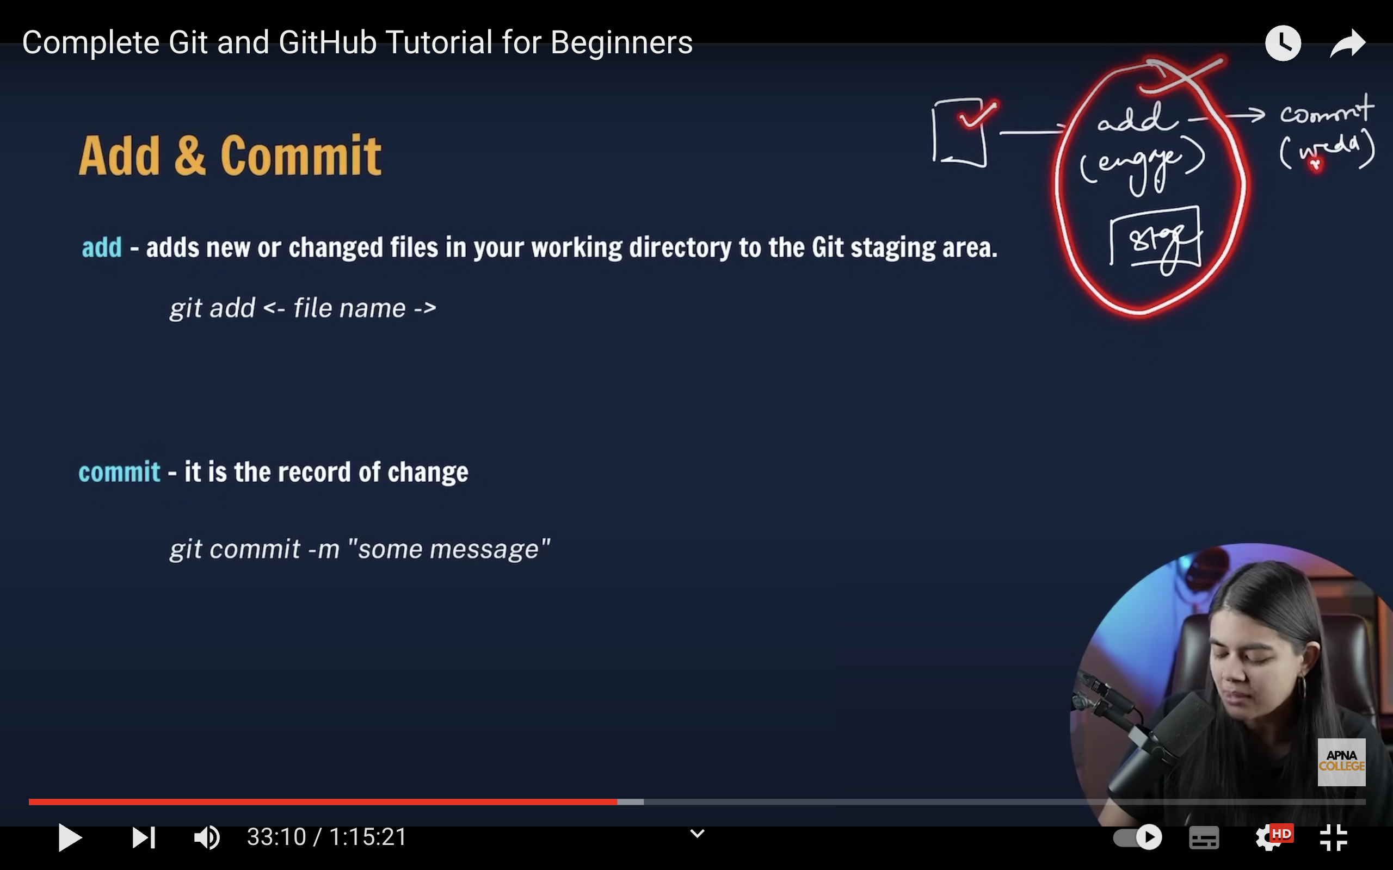

When we want to create the git repo on local machine itself and push on to the github account:

Or in other words

If we want to initialize git in our local folder where we have done a project

There we uses init command

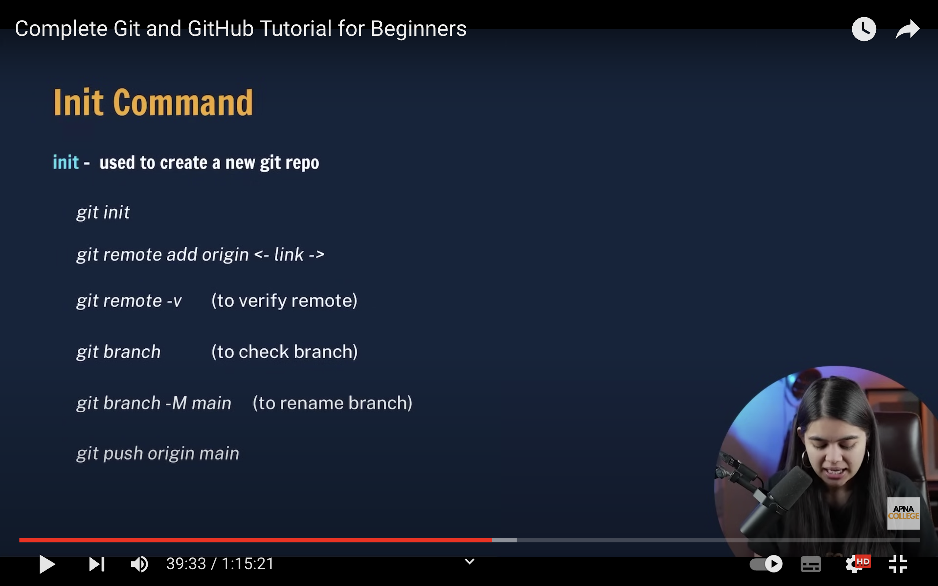

1)Git init: see u created a folder hansi then if u open terminal in that and enter git init then local repository(repository in local system) will be created as In below image

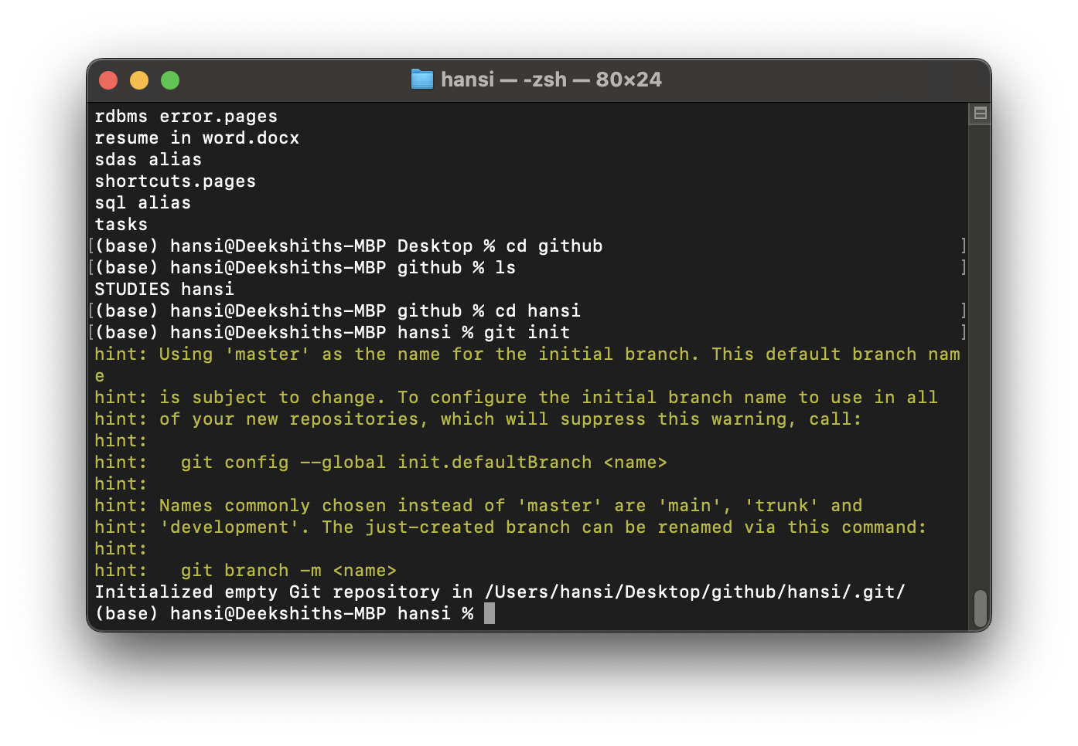

The default main in local repository is master not the main as in below picture:

So now the folder is termed as a local repository

2)git remote add origin <link>

This command is used to link a remote repository to the local repository

The link here is the https or ssh link of repository on the github server side to which u want to push the local repo

See below image

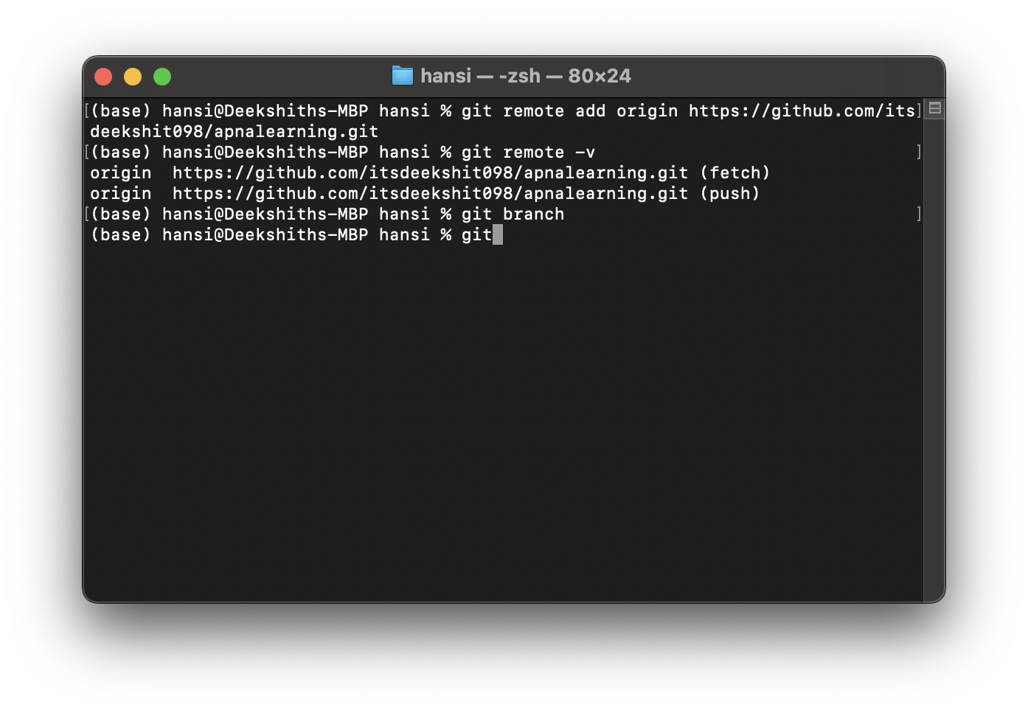

Git remote -v: to verify to which remote repository u linked ur local repo

Git branch:to show in branch u are in

If branch Is not diplaying create ur main branch using below code

git checkout -b main

git branch -M main 🡺is used to rename the current branch we are in to any name(replace main to any name u want we uses main for no difficulties)

**git push origin main:** used to push the files in local repo to remote repo make sure to add and commit before pushing files

if u want to use the remote repo name instead of origin in the above code u should have used the remote repo name only while using this command git remote add origin <link>

u should use it as **git remote add remotereponame <link>**

**NOTE:**

**Master branch used to be the default branch before but now the default branch was changed to main branch**

**If u use the below code to push**

git push -u remotereponame main

-u resembles upstream which means that if u push using above code first time next time u can push by using just **git push**

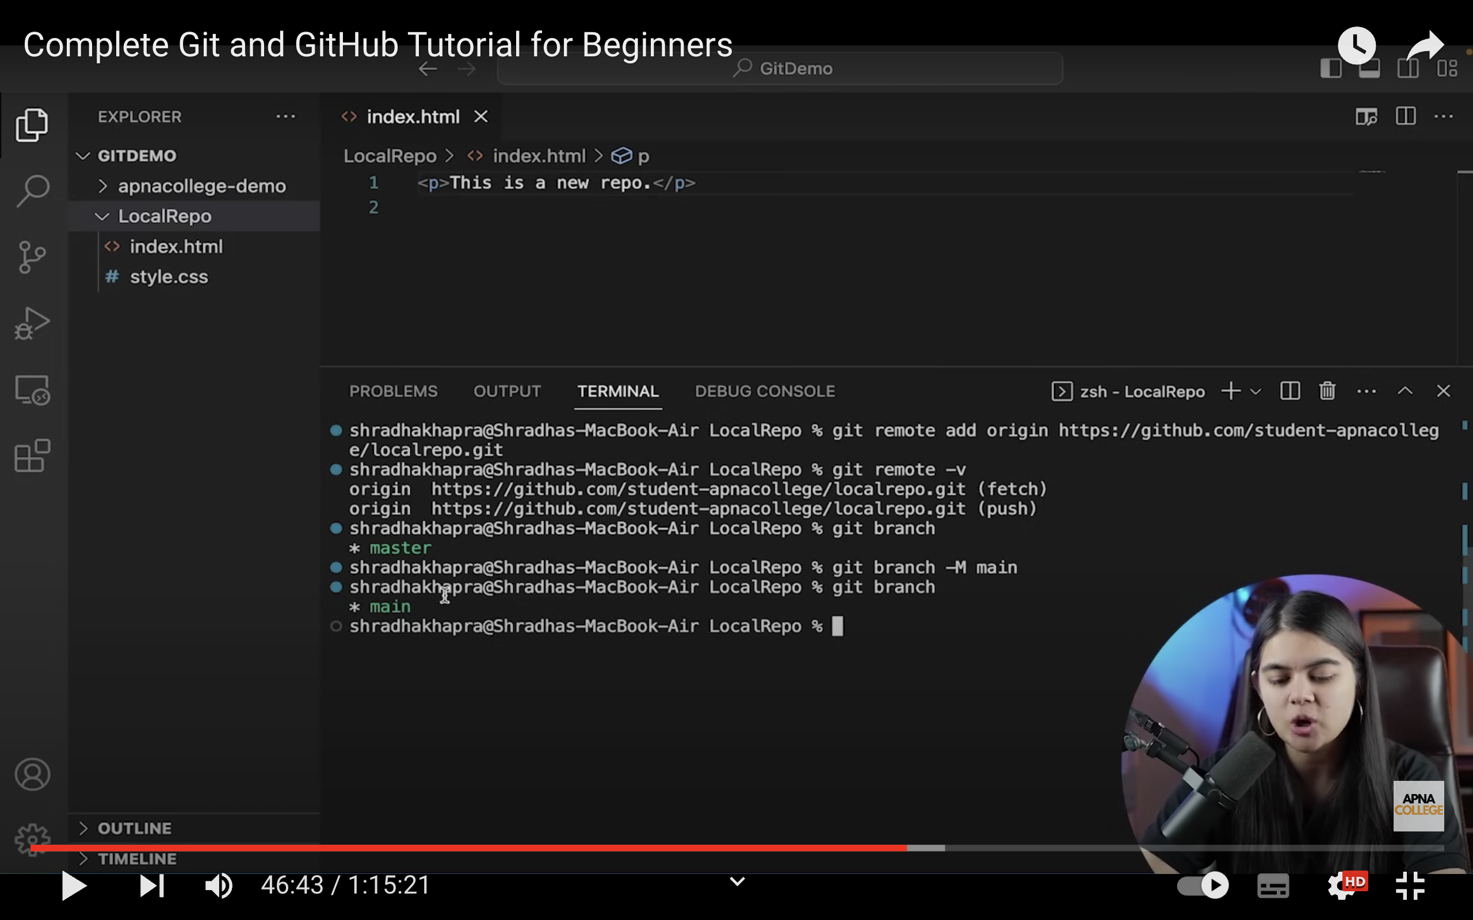

**BRANCHES**

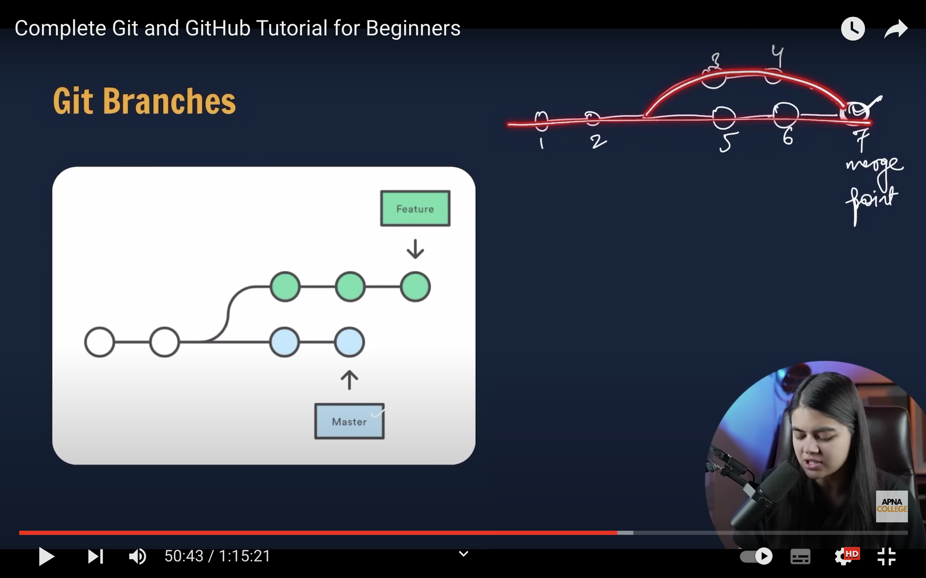

**What th**ese branches are:

* Look at above image rounds are assumed as commits and there tree is divided into two branches after commit what does it mean is see there was only one branch till the 2nd commit
* Say after 2nd commit there has a need that two different teams need to work on the thing those we have till now so a new branch (say hansi123) diveated from original branch main

The code to create such branch is :

1. First create a branch using below code:

git checkout -b newbranch_name(say hansi123 as exp)

1. **By above code branch is created in local repo only to make it reflect on remote repo it should be followed with push command**

git push origin newbranchname(say hansi123 as an ex)

* Now if u look at branches in remote repo u will be having the new branch hansi123 which will be having the contents which are there in the main branch till then
* So the whole thing is the newbranch will be having the things which main branch had after the 2nd commit and before the 3rd commit and from now on based on the push command the commit will be done say for ex:

Git push origin main 🡪commits will be pushed on to main branch

Git push origin hansi123🡺commits will be pushed on to the hansi123 branch

Based on the branch name in the git push command commit will be published in the respective branches

Here too u can use upstream command

Git push -u origin hansi123🡺if use only git push next time the commits will be pushed into hansi123 branch directly u need not to specify the origin hansi123 in git push command

So wholly branches are used when:

When from a particular stage(means after some commits) if one team or a person want to work on it separately he will be creating a branch that makes copy of code that they have until then and from then based on push command the commits will be published into specific branches

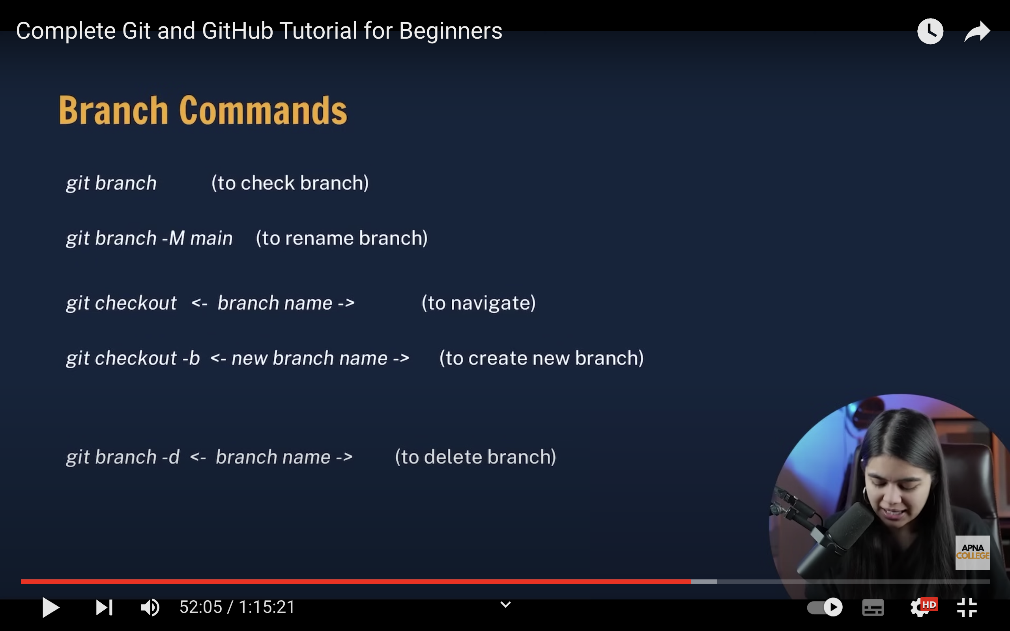

**Git branch to check in which branch we are in :**

**Git branch -M main to rename the current branch we are in**

**PULL. COMMAND:**

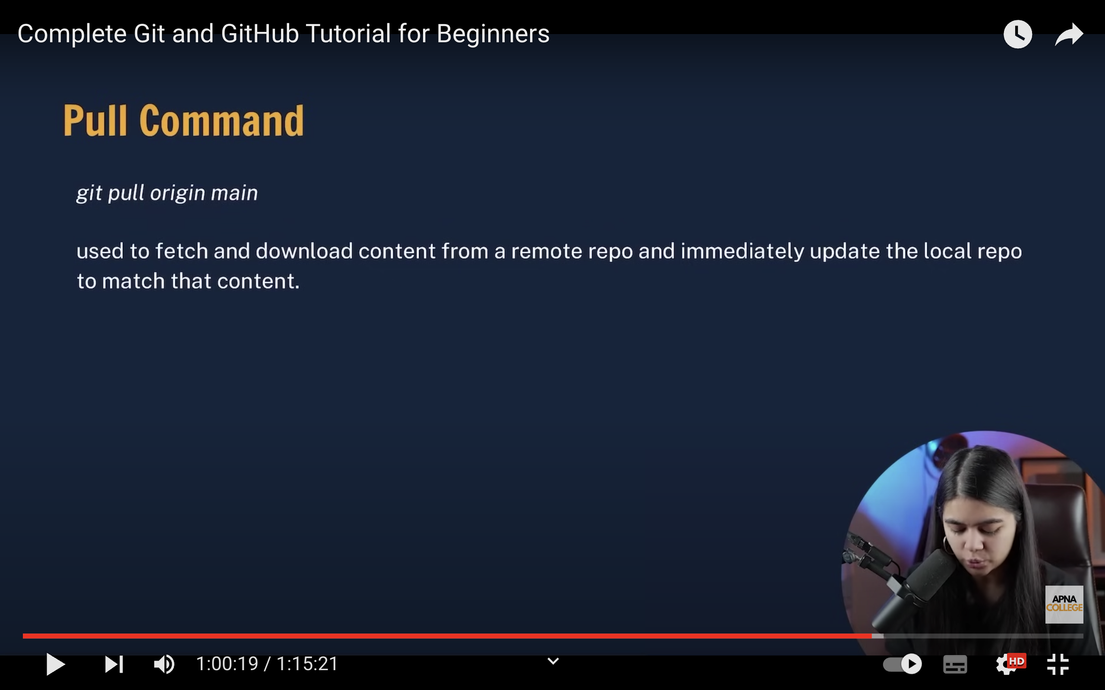

**MERGING:**

